

**Roaming Round Romsey**

**The Cupernham Way**

**Overview***:*

In this topic we will be learning about human and physical features within our local area and in a fictional fairy tale land. I will use this knowledge to describe a route on a map, using geographical language.

**By the end of this unit…**

I will understand that our local area is called Romsey which is located in Hampshire in the south of the UK.

I will be able to use photographs and plan, draw and describe routes on a map to recognise landmarks and basic human and physical features.

I will use simple fieldwork and observational skills to study the geography of my local area and the key human and physical features of the surrounding environment.

**What I already know…**

In year 1, I went on a walk in our local area and created a 3D map of our school.

**Key Vocabulary**

|  |  |  |
| --- | --- | --- |
| Map | Local area | North/South |
| **Human features**  Near/Far | **Physical features**  Left/Right | East/West  Landmarks |
|  |  |  |
|  |  |  |

**Relevant geographical features**

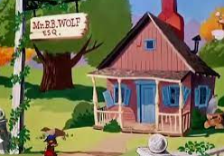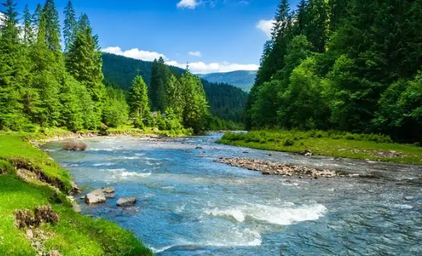

**Key Questions**

**Where do we live?**

**Can you identify human and physical features?**

**Using geographical language, can you describe the way to Mr Wolf’s house?**

**How can we use photos to create a map of our local area?**

